KELLY L. MILLER

Address: 4680 Maplegrove Ave. NE, Louisville, OH 44641

Father Cell Phone: 330-705-6055 Mother Cell Phone: 330-417-6061

Parents’ email: sharon_5@yahoo.com / markm@rhsonline.net

Date of Birth: 10-9-1995 Age: 18

G.P.A.: 4.3 (wgt) on a 4.0 scale Graduation Year: 2014
Class Rank: 7 out of 240

Height: 5’4” Weight: 114

High School: Louisville High School (Division 1-Stark County)
1201 S. Nickelplate St.
Louisville, OH 44641

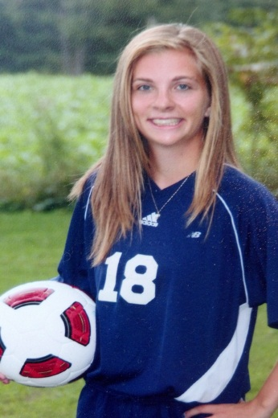

Academics: <honors classes>
<ACT or SAT scores>
<extra educational classes, projects or presen>
<academic awards>
Write an email tavimuresan@yahoo.com

High School Team: Louisville Leopards Colors: Navy, Lt. Blue & White

Coach: Tony Volpe Position: Defender
330-284-5765 Jersey Number: 18
Coach email: avolpe@massillonschools.org Year: Sr., Jr, So, Fr.

H.S. Soccer: 4-year starter & Varsity Letterman, 2013 Captain,, Team Defender MVP 2013, 2012 & 2010
Over 4 Seasons: Recorded 7 saves , over 375 defensive interceptions, 100 steals, 3 assists, & 1 goal. 2013 & 2012- 1st Team All Northeastern Buckeye Conf & 1st Team All Stark County
2013 & 2012 2nd Team Greater Akron District 1 Team, , 2013-10 Scholar-Athlete Award

2013 & 2012 Evaluation Soccer Video: http://lousivilleleopards.org/kellymiller
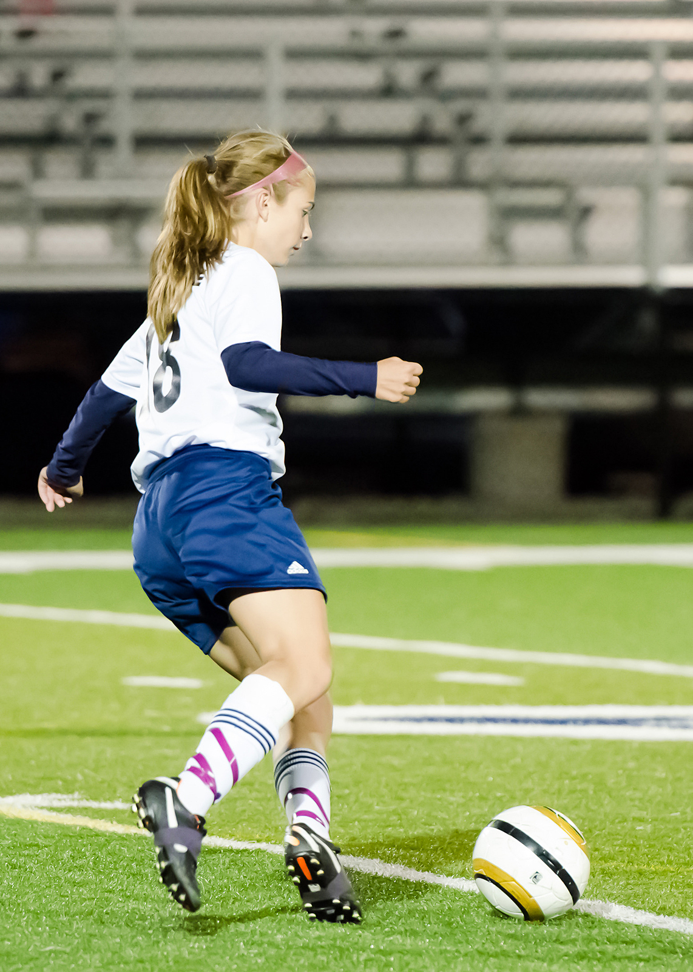

Other Activities:
2013 Summer – Played for Canton United Soccer Club
2013 & 2011 HS Track Team
2009-2012 4.0 GPA Award, National Honor Society,
2011,’12 Louisville Concert Choir & Louisville Lyrics Show Choir
President of Louisville Teen Institute, VP of German Club,
VP of Drama Club, Jr. & So. High School Play and Musical,
Sept 2013 Alliance, OH Elks Lodge 467Student of the Month
2013 School Rep for Ohio Buckeye Girls State Political Camp

Post High School Education: Four-Year College, major Physics

Club Team: Everest Soccer Club Colors: Black, Red

Coach: Nate Rausch Position: Defender & Midfielder

330-858-2976 Jersey Number: 13
Coach email: rauschnw@ hotmail.com Club Year: Spring 2011-Spring 2013 Season Goals: 11

Club Team: Blue Raiders Futbol Club Colors: Navy & White

Coach: Carol Stefanik Position: Defender & Midfielder

Carol.stefanik@deibold.com Jersey Number: 13
330-412-6180 Club Year: 2007-2012

Strengths: Speed, Tenacity, Positive Attitude

